Straightening Edge loops
9-21-2026
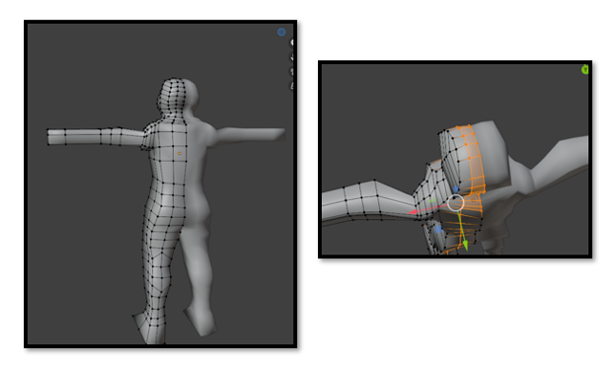

Select an edge loop that needs straightening. Hit S a string will appear then hit either the letter X or Y on the keyboard I actually straightened mine by using Y. But it will depend on what needs straightening.

